In order to move our applications from a home-grown security system to an industry standard identification and authorization system to help protect access to our records in addition to supporting the vision of a single login across PRI Applications, the login for eAuditNEt has changed.

Rather than logging in from the main page, you will click the login button to be directed to the new login.
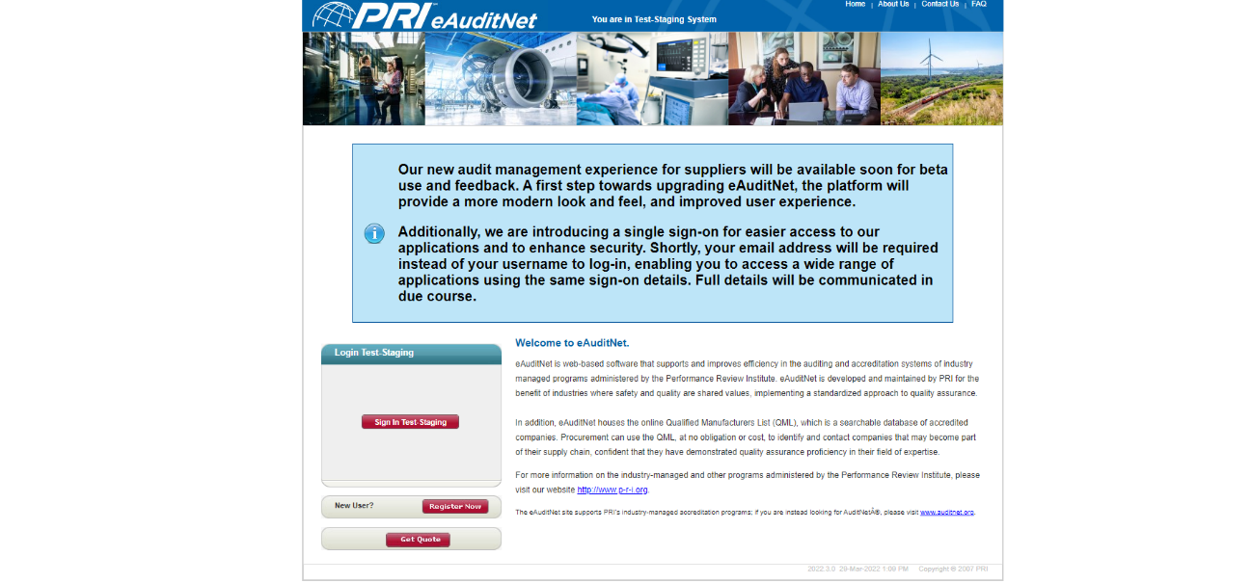

If you have a PRI Login, you will be able to enter it from there. Users Names are no longer used, email address is the ID.
If this is the first time you are coming in to the new login screen, you will have to select the “forgot password” link
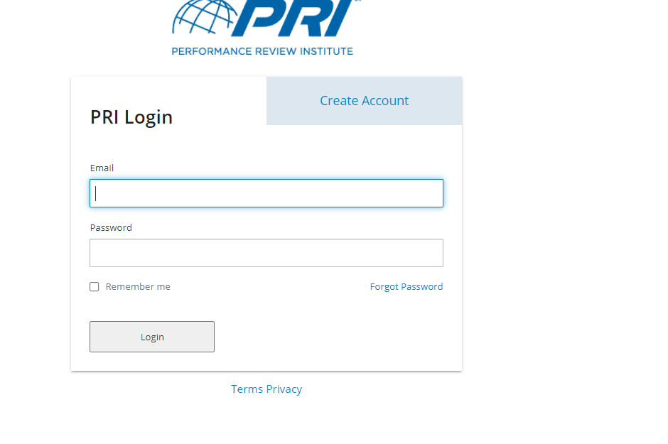
After that, just enter your eAuditNet email address and the system will walk your through changing your password.
